Preliminary Test Program for Friction Stir Processed Aluminum Stiffeners applicable to the Navy Littoral Combat Ship

Prepared by:
Kyle White

Faculty Advisors:
Dr. Damon Fick
Assistant Professor, Civil and Environmental Engineering

Dr. Michael West
REU Site Director, Department of Materials and Metallurgical Engineering

Dr. Alfred Boysen
Professor, Department of Humanities

Program Information:
NSF REU Site Award #1157074

South Dakota School of Mines and Technology
501 East Saint Joseph Street
Rapid City, SD 57701

Table of Contents
Abstract 3
Introduction 3
Fabrication Methods 4
Current Method 4
Proposed Method 6
Broader Impact 9
Procedure 9
Materials 9
Equipment 10
Testing 11
Specimens 11
Data and Results 14
Load Displacement 14
Failure Mechanism 15
Discussion 16
Conclusion 16
Future Work 16
References 16
Acknowledgments 17

Abstract
South Dakota School of Mines and Technology is currently involved in examining the strength of friction stir processed AA 5083-H 116 Aluminum Alloy stiffeners which are used to create the super-structure of the Navy Littoral Combat Ship. South Dakota School of Mines & Technology has completed the preliminary testing stage to determine the best boundary conditions for the Navy stiffeners. The three boundary conditions which were under consideration were stiffeners with bearing plates tack-welded, bearing plates fully-welded, and stiffeners with no bearing plate welded. The specimens also had strain gages applied to measure stresses applied from a Tinius Olsen. The results from the data concluded that the aluminum stiffeners with the tack-welded bearing plates exhibited the ideal conditions for strength testing; due to the high loads, consistencies in failure mechanisms, and the minimal mechanical property changes.
- Introduction
During the past ten years the Navy has progressed from basic Friction Stir Welding (FSW) research and development into full scale production on two large ship building programs - the Joint High Speed Vessel (JHSV) and the Littoral Combat Ship (LCS) (Widener, Fick, & Tolle, 2012). The size and nature of these programs demands a more agile approach to not only producing a high quality friction stir welded joint - but being able to complete non-destructive testing in a responsive timely and affordable manner. Additionally, the geometry of the welds on some of the multi-void hollow extrusions prevents a thorough visual inspection on the top and bottom of the weld joint (Widener, Fick, & Tolle, 2012).
The U.S. Navy began implementing friction stir welding technologies into the manufacturing of Navy ships in 2004, beginning with the fabrication of stiffened panels on the Office of Naval Research’s (ONR) X-craft ‘Sea Fighter’ program (Smith, Mishra, Mahoney, & Moen, 2009). In 2005, another of application for friction stir welded stiffened panels was developed for the Littoral Combat Ship designed by both Lockheed Martin and General Dynamics using AA 5454-H111 and AA 5083-H111, and AA 6082-T6 aluminum alloys. In early 2009, the Landing Helicopter Assault (LHA) 6 program went into production using FSW in the manufacture of its 5XXX series aluminum superstructure, with the approval of NAVSEA (Widener, Fick, & Tolle, 2012).
A new method for fabricating aluminum stiffeners, girders, and frames for Navy Ship Applications has been introduced by Friction Stir Link (FSL) and its partners (Smith, Mishra, Mahoney, & Moen, 2009). The new approach uses partial penetration friction stir processing (FSP) with ensuing bending to manufacture stiffeners, girders, and frames for ship superstructure. FSP/bending allows long-length sections to be manufactured without the need for using gas metal arc welded (GMAW) splices every 4 to 8 feet. This new method dismisses the need for the GMAW splices, yields a long-length structure with consistent properties along the length and moderates distortion.
South Dakota School of Mines and Technology has become involved because of its current ability and experience in friction stir welding. Furthermore, South Dakota School of Mines and Technology is involved to perform structural tests to confirm the hypothesis that the friction stir process stiffeners are meet or exceed the strength of non-processed stiffeners, to benchmark performance in the alloys, product forms, and thickness ranges currently planned for production in the Navy Littoral Combat Ship (LCS) utilizing FSW. This work could provide valuable data that could be presented before appropriate standards committees for review in support of broad agency FSW welding specifications, and could serve as a basis for vendor qualification (Widener, Fick, & Tolle, 2012).
South Dakota School of Mines and Technology is in the initial stages of this testing. Current testing is being performed to determine the boundary conditions for restraining the Navy stiffener test specimens. The boundary conditions that are currently under consideration are bearing plates fully welded to the stiffener, tack welded to the specimens and stiffeners without a bearing plate. Strain gages are applied to the stiffeners to measure the buckling loads in each condition. The data will be analyzed to determine the best boundary condition of restraint for when the preliminary testing program for the Navy stiffeners begins.
Work is currently in progress to develop an suitable approach to apply transverse and axial loads to the stiffeners while maintaining desired boundary conditions. A review of the published literature reveals welded connections have been used successfully (Widener, Fick, & Tolle, 2012). A welded base bearing plate provides for manageable means to apply a homogeneous compressive strength and create a fixed boundary condition. The welded connections also simulate the actual connections in the bulkheads or floorboards of the ship. Preliminary investigation has identified spot welding the stiffeners to the bearing plates, to reduce distortion or residual stresses from a continuous weld (Widener, Fick, & Tolle, 2012).

2.0 Fabrication Methods
The descriptions and figures of the two different fabrication methods below are summaries from the report by Smith et al. (Smith, Mishra, Mahoney, & Moen, 2009)
2.1 Current Method
The current method for fabricating aluminum stiffners is time consuming and costly due to need for splicing sections on stiffeners together using gas metal arc welding (GMAW). The current method of fabrication involves a number of operations to fabricate the stiffeners.

Operation 1: Cutting of flat aluminum plate or sheet into sections to a predetermined width. It is crucial to note that the sections are cut in the width direction (transverse to rolling direction) of the plate, due to the exceptional ductility of the material perpendicular to the rolling direction. This unfortunately restricts the length of any individual section to the width of the plate, which is usually less than 6 feet. Figure 1 illustrates this process.

Figure 1: cutting schematic (Smith, Mishra, Mahoney, & Moen, 2009).

Operation 2: Notching via machining, water jet cutting, or other processes. This allows the stiffener to fit into place with the base structure with the component of the smaller longitudinal stiffeners. Figure 2 illustrates this process.

Figure 2: notch locations (Smith, Mishra, Mahoney, & Moen, 2009).

Operation 3: Forming of the stiffener to a right angle with a rather large radius, to avert cracking of the aluminum. The forming is typically implemented with the radius approximately 4 times the thickness (4T) of the stiffener. Figure 3 illustrates this process.

Figure 3: bend placement (Smith, Mishra, Mahoney, & Moen, 2009).

Operation 4: Splicing of the individual sections is necessary via gas metal arc welding (GMAW) to create a stiffener longer than the width of the plate. Figure 4 illustrates this process.

Figure 4: GMAW splice locations (Smith, Mishra, Mahoney, & Moen, 2009).

2.2 Proposed Method
Operation 1: Cutting of flat aluminum sheet into sections to a predetermined width. It is critical to note that the sheet is cut in the length direction (parallel to rolling direction) of the sheet, which is inversely applied to that of the traditional approach. This allows for the length of any individual section to be cut to the length of the sheet, which is usually a minimum of 20 feet. Sheets of up to 40 feet in length can be obtained. Figure 5 illustrates this process.

Figure 5: cutting schematic (Smith, Mishra, Mahoney, & Moen, 2009).

Operation 2: Notching via machining, water jet cutting, or other processes. This allows the stiffener to fit into place with the base structure with the component of the smaller longitudinal stiffeners. Figure 6 illustrates this process.

Figure 6: notch locations (Smith, Mishra, Mahoney, & Moen, 2009).

Operation 3: Friction stir processing (FSP) of the section in the flat position along the full length of the impending bend line. FSP utilizes a single pass, partial penetration tool to a depth approximately 40% of the thickness of the aluminum plate, at a reasonable travel speed and tool rotation rate. In the friction stir processed zone, the microstructure will be an equiaxed, fully recrystallized fine grain microstructure (Smith, Mishra, Mahoney, & Moen, 2009). Adjacent GMAW Includes Pre-Weld Prep and Post Weld Grind and Distortion Remediation to the FSP zone there will be a conventional heat affected zone (HAZ) and unique to FSP a very small thermo-mechanical processed zone (Smith, Mishra, Mahoney, & Moen, 2009). However, the HAZ volume will be less than that experienced with fusion welding due to the reduced heat input, shorter thermal cycle, and the shallow tool penetration (Smith, Mishra, Mahoney, & Moen, 2009). As part of this operation, the friction stir processed surface will be ground after FSP. There is little to no flash, but the FSP tool does leave a shallow (<0.001 inch deep) swirl pattern on the surface (Smith, Mishra, Mahoney, & Moen, 2009). Until tests prove this pattern is not detrimental, it will be removed by grinding prior to bending. Figure 7 illustrates this process.

Figure 7: FSP path (Smith, Mishra, Mahoney, & Moen, 2009).

Operation 4: Forming of the stiffener to a right angle with a relatively small radius. Bending for this application is envisioned to be accomplished in a press brake, though roll forming could be used. Selecting between press brake and roll forming requires considerations of cost, technical issues, and practical concerns, if important, roll forming, because it is progressive and is in longer contact with the dies, has less spring back and thus more repeatable dimensional accuracy in the final part and less initial scrape (Smith, Mishra, Mahoney, & Moen, 2009). Further, the tooling costs for roll forming are higher and unless the quantity is large, press break forming is more cost effective (Smith, Mishra, Mahoney, & Moen, 2009). Each approach can harbor many different thicknesses. Also, since the stiffeners are notched, and assuming this is more practical and economical in the flat position, press brake forming may be more adequate unless notching can be implemented superseding roll forming (Smith, Mishra, Mahoney, & Moen, 2009). Unfortunately, there is no information available concerning differences in metallurgical issues such as the magnitude of strain-hardening and resultant residual stress (Smith, Mishra, Mahoney, & Moen, 2009). However, a comparison of properties between the different forming approaches could be considered. The FSP zone will be on the tension surface, with the centerline of the bend aligned with the centerline of the FSP zone. Bending introduces strain-hardening and thus adds to the strength of the stiffener (Smith, Mishra, Mahoney, & Moen, 2009). Figure 8 illustrates this process.

Figure 8: bending placement (Smith, Mishra, Mahoney, & Moen, 2009).

3.0 Broader Impact
Through the proposed method for fabricating stiffners, girders, and frames can lead to compelling cost reductions, advanced material properties, and advanced component performance. With the new method partial penetration friction stir processed stiffeners, girders, and frames, the manufacture time can be greatly reduced; allowing the Navy to implement new ships into its fleets at an improved rate.
This exploration of friction stir processed alloys has flooded over into the educational institution of South Dakota School of Mines and Technology thanks to their experience and knowledge in the friction stir welding technique. This experience will allow students to have an immeasurable experience with working with government agencies and projects and advanced and sophisticated as the one currently being explored.

4.0 Procedure
4.1 Materials
AA 5083-H116 Aluminum Alloy Stiffeners
CEA-06-250-UN-120 Strain Gage
Bondable Terminals- CPF-100C
M-Bond 200 Adhesive Kit

  - Equipment
National Instruments NI 9235/9236 8-Channel, 24-Bit Quarter-Bridge Analog Input Module
Tinius Olsen

  - Strain Gage Installation
For the tests performed; CEA-06-250 -120 and CEA-13-250 -120 gages were used. The test specimens were prepared in this sequence:
- Surface Abrading: to remove loosely bonded adherents (rust, scale, paint, galvanized coating, oxides, etc.) and to develop a surface texture suitable for bonding.
- A rough grit sand paper was first used followed by a fine grit sand paper. The grit size does not matter for this process.
- Gage Location Layout Lines:
- Mark surface with a pair of crossed referenced lines at the point where the strain measurement is to be made.
- The lines are made perpendicular to one another with one line oriented in the same direction as the measurement.
- Lines should be made with a tool that burnishes.
- Surface Conditioning
- Conditioner should be applied repeatedly
- Keep surface wet with the conditioner.
- Scrub surface with cotton until the cotton is no longer discolored.
- Make sure to make cleaning strokes in one direction.
- Pick up cotton after each stroke to keep from stirring the contaminants back into the cleaned area.
- When the clean the surface should be dried with one slow swipe of a gauze sponge
- Gage Application:
- The gage is then installed so the triangular index marks defining longitudinal and transverse axes of the grid are aligned with the reference lines on the test surface.
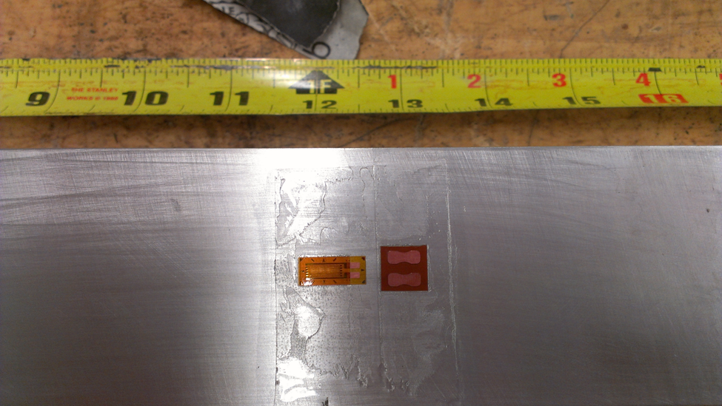
Figure 9: installed strain gage on aluminum stiffener.
  - Testing
Specimens will be tested with bearing plates tack welded, fully welded and no bearing plates attached to determine the best boundary conditions for restraint. The specimens were placed inside the Tinius Olsen with the strain gage lead wires being connected into the National Instruments NI 9235/9236 8-Channel, 24-Bit Quarter-Bridge Analog Input Module. Data was recorded using software, as well as using the Tinius Olsen

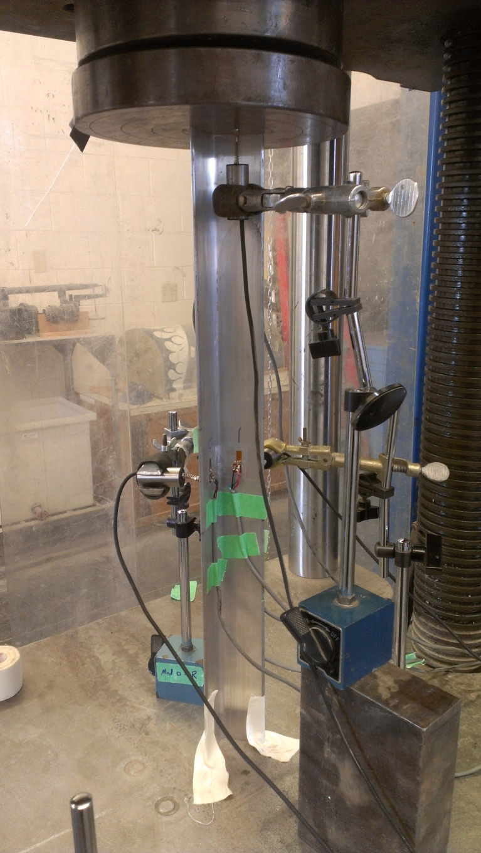
Figure 10: aluminum specimen test setup inside the Tinius Olsen.

4.5 Specimens
The test specimens were scaled down aluminum stiffeners to determine the best boundary condition for restraint. The stiffeners were 24 inches in length, the “legs” of the stiffeners were approximately 2 inches in width, and had an approximate thickness of 0.134 inches.
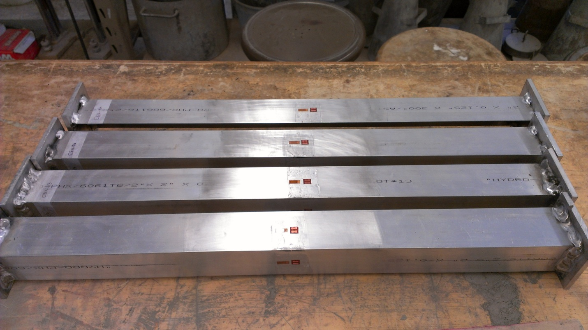Figure 11: test specimens with strain gages applied.

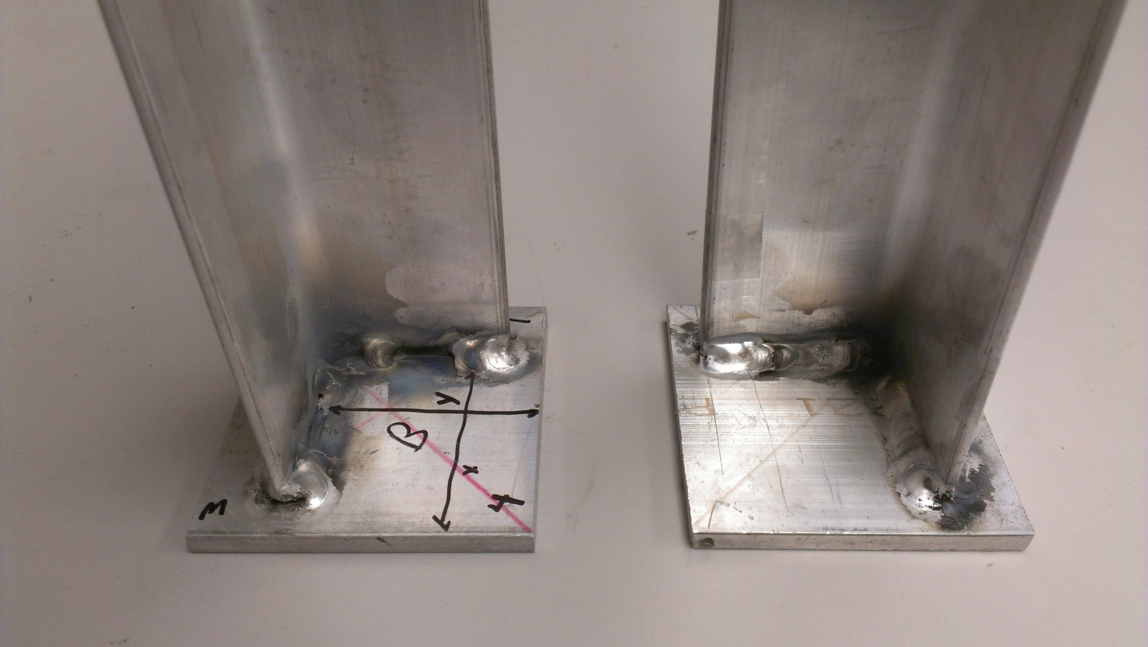Figure 12: specimens with tack welded bearing plate and fully welded bearing plate respectfully.

- Results to Date
The preliminary tests for the axial loadings have been completed. The results below are interpreted from the data recorded from the Tinius Olsen.
5.1 Load Displacement

Figure 13: load displacement results from the Tinius Olsen data.

  - Failure Mechanism

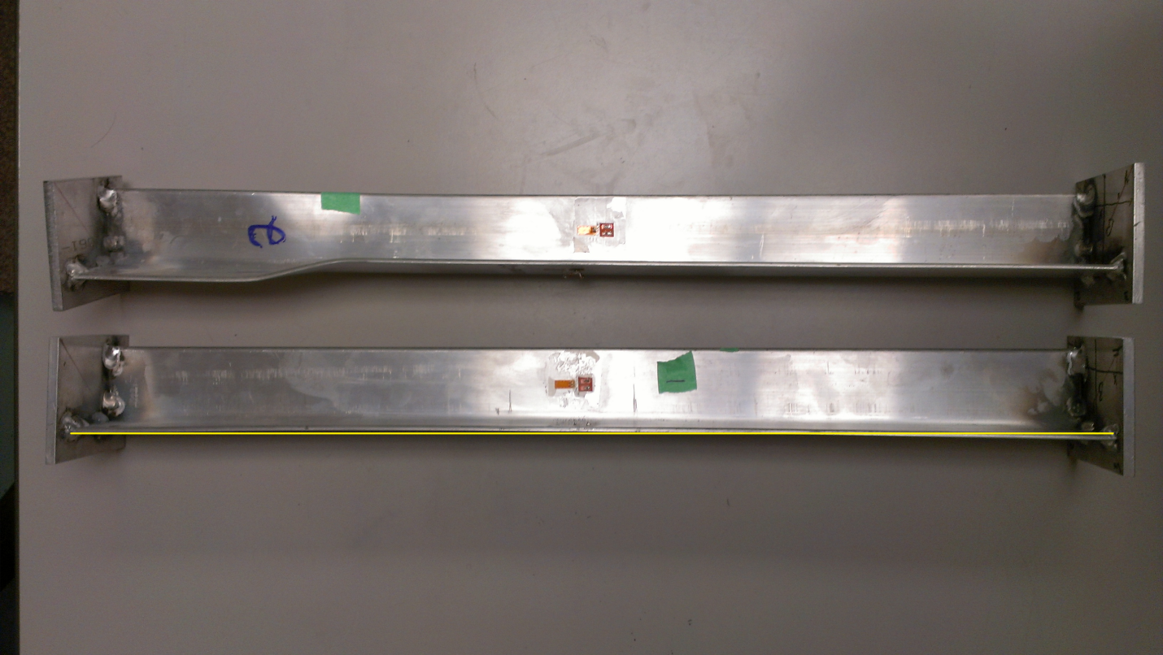
Figure 14: tack welded specimens with failure outside the support.

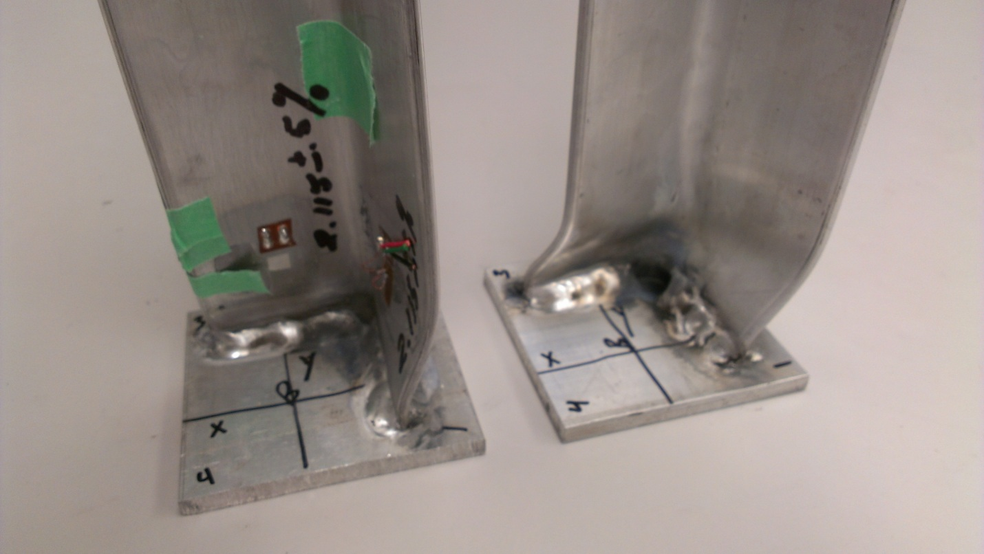
Figure 15: fully welded specimens with failure at the support.

5.3 Discussion
From the Tinius Olsen data the fully welded specimens failed at an average load of 8465 lbs. Failure at the support occurred in the fully-welded plates this may have occurred due to changes in mechanical properties when welding was performed. Tack-weld specimens failed at an average load of 10066 lbs. Failure outside support occurred in the tack-welded plates, resulting in the highest buckling loads of the three boundary conditions tested. Non-welded specimens failed at an average load of 8175 lbs.

5.4 Conclusion

The tack-welded specimens exhibited a change in slope at 87% of the maximum load. A slight “bow” was observed in the second linear section and the permanent deformations began happening on the down slope of the load displacement curve. The tack-welded specimens also exhibited bilinear behavior in both specimens. Due to the high loads, consistencies in failure mechanisms, and the minimal mechanical property changes, the tack-welded plates will be used in the Navy stiffener testing program.
5.5 Future Work
South Dakota School of Mines & Technology will continue the testing of the Navy stiffeners. The testing program includes; test stiffeners in compression and in bending, testing coupons in tension, fabricated with both methods, and to quantify their section properties and behavior. The properties will be used to validate a Finite Element Model (FEM) of different panel geometries. Further completion of this work will cover structural testing of the stiffened marine panels for a second validation of the FEM. The overall objective of these tasks is to determine a quantifiable performance and fabrication benefit to using FSP stiffeners on the LCS.

References
Smith, C., Mishra, Mahoney, M., & Moen, C. (2009). Material Property Testing Towards NAVSEA Apprval for Use of Friction Stir Processing to Fabricate Marine Stiffeners. Brookfield, WI: Friction Stri Link Inc.
Widener, C., Fick, D., & Tolle, C. (2012). Life Extension of Navy Weapon Systems Through Advanced Materials Processing Using Benchmarking and Best Practices. Rapid City: South Dakota School of Mines and Technology.

Acknowledgments
I would like to thank Dr. Michael West for giving me the opportunity to work with some of the brightest students around the country, thank you Dr. Damon Fick, Dr. Kjerengtroen, Lucas Fried, and Kyle Johnson for allowing me to be a part of the research team, and thank you Dr. Alfred Boysen for showing us everything we need to succeed in our professional careers. Also I would like to give a special thank you to the National Science Foundation REU Site Award #1157074 which has allowed students to gain experience and knowledge in research.

